**Computer Networks Lab (CS 353): Lab 7**

In this assignment you are going to understand the flow control service provided by the data link layer of the TCP/IP Protocol stack with respect to wired/wireless link properties. You are going to perform the following experiments using NetSim.

R1 and R2 are routers.

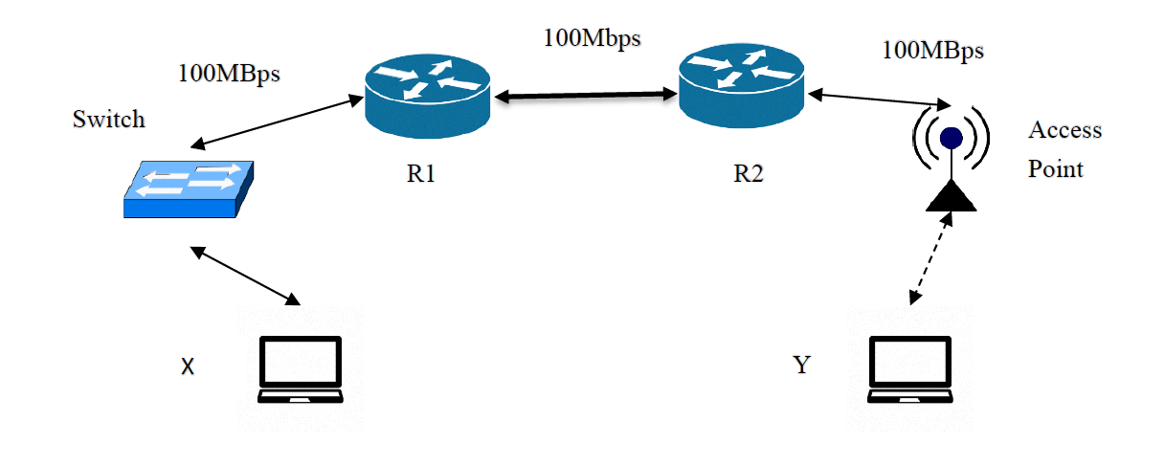

Build the given network topology. Start a CUSTOM application with packet size and inter-arrival time of packets exponentially distributed. A flow is initiated from host X to host Y. Run the simulation for 20 sec. You should note down the results in a Word/Excel file after analysing the packet trace file.

1. Note down the different link layer protocols you observe with respect to the different types of networks. [1 Mark]
2. Find out the address (both IP and physical) for each participating node in the network. [2 Marks]
3. Start an application on X sending data to Y. [2 Marks]

a. Note down the ratio of packets received to the packets transmitted

b. Note down the ratio of packets that are received in error to the packets transmitted

c. Note down the ratio of packets that have collided to the packets transmitted

d. Note down the total number of packets lost

e. Note down the throughput in Mbps.

f. Observe the MAC tables in the L2 switches and note down the entries

Repeat step 3 by starting an application on Y sending data to X.

1. Repeat the above experiment for flow X→Y with R1-R2 bandwidth increased to 1 Gbps. [2 Marks]
2. Repeat the above experiment for flow X→Y with Constant Bit Rate type application and packet size and inter-arrival time set to constant. [2 Marks]

6. Find out the data link layer payload size and header size for the application data packets. [1 Mark]